HDCOMP Server Side Development Project Proposal:

Bespoke Ebook Retail Application

by

Liz Bourke

Amy Greene

Brian Merrill

Noun Mohamed

Contents

Our Proposal - Liz Bourke 3

Core Concepts/Entities - Liz Bourke 4

The Product For Sale 4

Registered Site User 4

The Customer Has A Shopping Basket 4

The Customer Purchases The Items In The Shopping Basket 4

Web Application Features - Liz Bourke 5

Search 5

Display Results 5

User Registration 5

User Profile (change password) 5

Login 5

Logout 5

Add to Shopping Basket 5

Remove from Shopping Basket 5

View Shopping Basket 6

Make Purchase 6

Process Flow - Noon Mohammed 7

Wireframe - Amy Greene and Brian Merrill 8

# Our Proposal - Liz Bourke

We're living through a literary boom, and an age of instability and change in the traditional bookselling marketplace. Where once books came only on paper, now a ebooks form a significant part of the publishing landscape, with over 700,000,000 million sold in English-language markets (outside of India) in 2018, with a total value above €1.5 billion.

A large proportion of these sales are what's known as "self-published" or "indie published" ebooks, where authors have eschewed a partnership with a traditional publishing house in order to take their product directly to the marketplace. That ebook marketplace is dominated by five major retailers (Amazon, Kobo, Google, Apple iBooks, and in the US, Barnes & Noble), each of whom take a cut of the sales in return for access to their respective digital ecosystems.

But most authors -- and nearly all self-published authors -- have a web presence separate from these retailers, in the form of their own websites. We propose to create an application that will allow those authors to sell their own ebooks directly to the consumer, without going through a retail middleman, and thus capture more value per unit sale.

The customer will be able to navigate to a specific URL associated with the author's website -- we'll call it www.authorpage.com\OwnSales for now -- where they'll be greeted with a Welcome, Visitor page and the option to browse the author's inventory -- or to search for a specific title. Visitors will be able to browse and search without registering, but will see a reminder to login/signup until they login or sign up.

Signing up requires accepting a privacy statement.

Signing up or logging in will deliver the user to a profile page, where they can see their order history (most recent orders) and change their password. They will then be able to continue to browse/search, but now they can add items to their Shopping Basket and complete their purchases.

# Core Concepts/Entities - Liz Bourke

## The Product For Sale

Books

Books are the primary product for sale on the website. They will have the following attributes:

* book_id: incremental value auto-assigned by Rails; primary key
* title: the title of the book
* description: a description of the book
* file-type: the file format (PDF, .mobi, .epub)
* publication_date: the year and month of publication
* unit_price: the price per book
* cover_image: the primary product image (minimum resolution, etc?)
* author: the author of the book (which will be assumed to be the owner of the website to which the OwnSales functionality is attached)
* ISBN: the ISBN, if one exists for the product

## Line Items and Orders

Line items.

Users registered with the website can make a purchase. Products (books) purchased will be recorded as line items associated with an order.

A line item will belong to a user.

A line item will belong to an order.

basket_id, customer_id, book_id, basket_subtotal, discount_applied

Orders.

When users make a purchase it will be recorded as an order.

An order belongs to a user.

An order can have many line items.

An order can have many books.

Attributes:

order_id

user_id

order_date

total

## Registered Site User (Customer)

Customer Entity

customer_id,

first_name,

last_name,

email (user-name)

password

## Registered Site User (Admin)

Administrators will have the same information as the Customer. However they will also have access to a backend area. This will be found atwebsiteurl.com/admin. This admin area, accessed by anyone not logged in, will result in a redirect to the login page. If the user is logged in but does not have the correct administrator level access, then they will be shown a message to inform them that theydo not have the correct permission to view this resource.If the user does have an administrator account, they can access the /admin area and viewall the vital CRUD controls for the website.

Admin CRUD

Administrators will have access to:

Create, View, Edit & Delete ​Books

Create, View, Edit & Delete ​Users

Create, View, Edit & Delete Orders

# Web Application Features - Liz Bourke

## Search

The search function will allow the user to search books by title, by series, and by price. When the "search" button is clicked, the request will be sent to the server and books that fit the criteria will be displayed on the results page.

## Display Results

The search results will be displayed on this page in the form of a list, with additional information for each entry. The search criteria will remain available at the head of the page and can be altered by the user at any point.

## User Registration

This allows the user to sign up to OwnSales by providing basic details: name, email address, and password. When registration is complete, user details will be stored in a database.

## User Profile (change password)

The user profile page will access user information from registration and display this information in a template. It will allow the user to update their information, including changing their password. It will also display the user's recent order history. Profiles will only be accessible to the registered user who owns them.

## Login

This will allow a registered user to sign in, using an email address and password that match the ones on file in the database. If a user sign-in fails, they will be prompted to sign in again or to register.

## Logout

This allows a registered user to logout of their session.

## Add to Shopping Basket

This allows a registered user to add a book to their shopping basket.

## Remove from Shopping Basket

This allows a registered user to remove a book from their shopping basket.

## View Shopping Basket

This displays the contents of the shopping basket in the form of a list, displaying book, price, and subtotal.

## Make Purchase

This allows the user to complete a purchase, updating order and payment tables in the database.

# Process Flow - Noon Mohammed

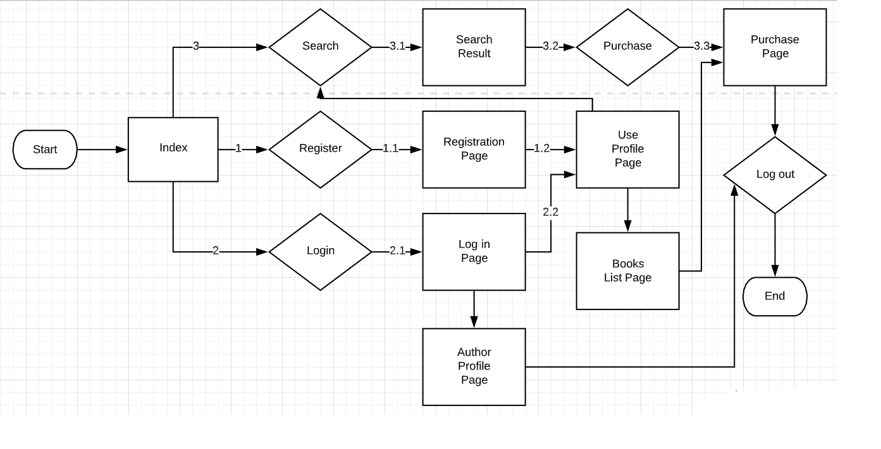

# Wireframe - Amy Greene and Brian Merrill

